Student worksheet

3.3 The nervous system provides fast control of the body

Pages 48–49 and 189

The stimulus response model

1 What would happen if your body could not respond quickly to stimuli?

2 Name 4 different stimuli that your body responds to.

3 Use the terms in the following word bank to create a flowchart that explains the stimulus-response pathway that your body exhibits when you step on a thumbtack with your bare foot.

|  |  |  |  |
| --- | --- | --- | --- |
| stimulus | sensory neuron | effector | motor neuron |
| interneuron | spinal cord | response | sense organ |
|  |  |  |  |
|  | | | | |

4 Use the words from question 3 to label the following diagram of the stimulus-response pathway and add arrows to indicate the pathway of the signal.

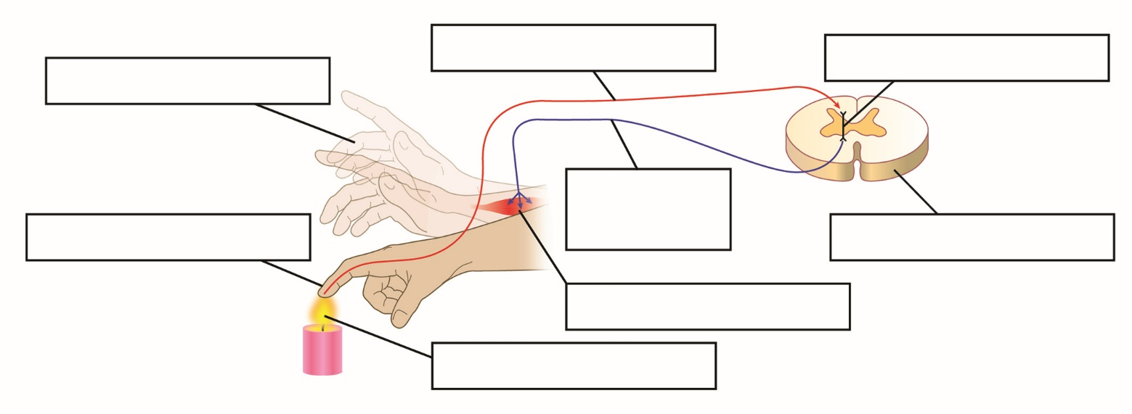

5 For the stimulus-response pathway outlined in question 3, state what each of the following are:

a stimulus

b sense organ

c effector

d response

6 What is a reflex action?

7 State 3 reflex actions, not on page 49, that your body experiences.